LGA Community Support Hub Template

How to use this document
This Community Support Hub Plan template it intended for communities’ groups to use and adapt to suit their circumstances.
Use this template alongside the LGA Community Support Hub Guide 2026. The Guide explains the principles, boundaries and good-practice considerations for planning and operating a CSH; this template helps communities document their local decisions, roles, risks, communication arrangements and operating procedures.

Working with the document
CAPITALISED TEXT in this template shows where the CSH should insert its own information, for example [XXX CSH].
Blue text is explanatory guidance and can be removed once the Plan is finalised.
Other text can be edited, deleted or added to suit the specific CSH.
Format the document including the title page, style and pictures as appropriate.

Stakeholders for the plan
When developing the CSH Plan, identify all the relevant stakeholders and engage them during plan development. Stakeholders might include community members, facility owners or managers, emergency services and the local council.

Key terms
This template uses the following terms. You can tailor local language, but the meaning should remain consistent to help manage community expectations and support alignment with formal emergency arrangements.
- Community Support Hub (CSH) / hub – A community-led local place and mechanism that helps people prepare for, and recover from, local emergencies and disruptions in their area.
- Community Support Hub management team – the local volunteer committee/group responsible for governance and year-round planning of the CSH, and for enabling the hub to operate when it opens.
- Community-led – Planned, governed and operated by local people and community organisations, with decisions made locally. Councils and agencies may support without directing day-to-day operations.
- Hub team – Persons who have completed the CSH’s (or partner organisation’s) registration process and is authorised to undertake defined roles within the CSH.
- Spontaneous volunteer – A person who offers help in response to a disruption or emergency without prior affiliation, registration, induction or training with the CSH or partner organisation. Spontaneous volunteers must be registered, briefed and supervised before undertaking tasks.
- Emergency Relief Centre (ERC) – A state-led centre established (when activated) to provide short-term essential support services to affected people. ERCs are not CSHs.
- Recovery Centre – A centre established during recovery (as part of formal arrangements) to provide access to coordinated information, services and support. Recovery Centres are not CSHs.
- Bushfire Safer Place (BSP) – A pre-designated built-up area of relative safety from a bushfire (not a specific building). BSPs are not CSHs.
- Bushfire Last Resort Refuge (BLRR) – A space or building intended to provide a minimum level of protection from radiant heat and direct flame contact as a last resort during a bushfire. BLRRs are not CSHs.

Resources to assist in developing your plan
Adelaide Hills Council has developed a library of e-resources that are available on the council’s website. In addition, specific resources have been listed under each section where directly relevant.

XXX Community Support Hub (CSH) Plan

XXX 20XX

CONTACT
NAME
EMAIL
PHONE

Contents
LGA Community Support Hub Template 0
1. What is the Community Support Hub? 4
2. Establishing Community Support Hub 7
Purpose of the [XXX CSH] 7
Our community 8
Location and facilities 11
Bushfire Safer Places and Last Resort Refuges 12
3. Governance 13
4. Hub team roles and responsibilities 18
5. Site safety 21
6. Managing community expectations 23
7. Building community awareness and social connections 24
8. Exercising and reviewing the plan 25
9. Funding opportunities 26
10. CSH Operation 28
Opening and closing the CSH 28
Supporting impacted community members 30
Hub resource kit 31
Public Information Board 31
Needs and Offers 33
Procedures and supporting information 34
Appendix A: Roles Cards 35
Hub Lead 35
Information Support 37
Community Support 40
General Hub Support 42
Catering Officer 43
IT Support 44
Spontaneous volunteers 45
Appendix B: Spontaneous Volunteer Registration Form 46

- What is the Community Support Hub?
The [XXX CSH] aims to support local preparedness and community connection by working with community members, local groups and services, council, and emergency services. This may include helping the community understand local risks, prepare for disruptions, and support each other when local needs arise.
During the planning phase, the [XXX CSH] plans to work with the community to build preparedness, strengthen local connections, and identify how the CSH may assist if it opens. The activities of the [XXX CSH] will reflect local strengths, local capacity, and the agreed purpose of the hub.
The [XXX CSH] may open to support the community during local disruptions or after emergencies, where it is safe to do so and there is a clear local need.
This may include events such as: extended power outages, periods of extreme heat, storms, bushfire, flood, or a major accident or collective trauma affecting the community.
The [XXX CSH] will only open when it is safe to do so. At a minimum, the CSH will not open if the building cannot be accessed safely, if the building or access route is affected by road closures or site safety hazards, if the location is within a ‘Watch and Act’ or ‘Emergency Warning’ area, or on days of forecast Catastrophic Fire Danger Rating for the CSH location.
Warning areas can change rapidly and must be monitored closely. Where there is no direct threat at the site, a CSH may open during extended disruptions (e.g., prolonged power outages, water shortages or periods of extreme heat).

Benefits of a CSH
The [XXX CSH] aims to strengthen preparedness, support local connection, and enable practical community-led support when disruptions or emergencies affect the area.

Building community preparedness
The [XXX CSH] aims to support community preparedness by strengthening local connections, building awareness of risks and capabilities, and helping the community prepare to support itself and others when disruptions or emergencies occur.
This may include:
- increasing social connections within the community and with local groups and services
- understanding community strengths, local skills, resources and networks that may be drawn on to assist impacted community members
- raising awareness about local risks, official emergency messaging, and the steps individuals and communities can take to reduce impacts
- developing and maintaining links with the council, emergency services and other relevant agencies to support two-way communication and coordination
- planning for when a CSH opens, including defining the CSH purpose, activities, volunteer roles and other practical requirements
- supporting structured and well-managed volunteering, including planning for the safe use of spontaneous volunteers where appropriate
- ongoing learning, knowledge sharing, and continuous improvement of community hub processes.

Support for impacted community members
When open, the [XXX CSH] aims to support impacted community members by providing short-term, practical, community-led support, sharing trusted information, and helping the community stay connected. This may include:
- providing early local support while formal relief or recovery arrangements are still being established, where appropriate
- sharing emergency services’ official warnings and advice
- providing practical assistance (including social connection, refreshments, power, water, Wi-Fi)
- matching individuals’ requests for basic support with available community resources, local skills and networks
- helping impacted community members learn about available services and possible sources of assistance
- working with local government and state agencies to convey community needs and the community’s capacity to cope with impacts
- contributing to recovery processes and supporting a smoother transition to other relief or recovery arrangements where they are activated
- supporting other impacted communities where this aligns with the purpose and capacity of the [XXX CSH].

Role of council in enabling the CSH
The [XXX CSH] is a community-led initiative. Councils and other organisations can play an important role in enabling CSHs, while local decision-making and day-to-day operation remain with the community.
Council support may differ depending on local capability, responsibilities, available resources and the nature of the relationship with the CSH. The [XXX] council may assist the [XXX CSH] by: [ENGAGE WITH COUNCIL TO IDENTIFY IF AND HOW THEY MIGHT BE ABLE TO ASSIST THE CSH AND ADJUST THE LIST BELOW AS APPROPRIATE]
- sharing information relevant to local risks, emergency arrangements, preparedness and recovery
- providing advice on good practice, safety, risk management and community engagement
- helping the CSH understand how it can complement formal emergency relief and recovery arrangements
- supporting communication and connections between the CSH, community groups, services and relevant agencies
- providing or facilitating access to planning tools, templates, training or other practical guidance
- supporting discussions about venues, facilities, local networks or other place-based arrangements
- in some circumstances, providing modest practical support, equipment or funding.
The [XXX CSH] is responsible for its own governance, planning, volunteer arrangements, operating decisions and communication about what the hub can and cannot provide.

What the CSH is not
The CSH will not become, operate as a formal emergency management facility or service delivery centre. A CSH does not replace or become any formal emergency centre or place, such as:
- Emergency Relief Centre (ERC)
- Recovery Centres
- Bushfire Safer Places
- Bushfire Last Resort Refuges
The CSH is not a place to relocate to during an emergency (e.g., bushfire, storm or flood). Individuals should follow their personal emergency plan and official emergency service advice. The CSH does not provide government grants or case management, overnight accommodation, medical facilities, or professional advice (although it may refer people to community services).
To support a coordinated approach, Hub volunteers should have a general understanding of these official centres and their roles. The CSH will share this information with the community year-round and well ahead of any emergency to help prevent confusion.
Emergency Relief Centre | Recovery Centre | Bushfire Safer Places and Last Resort Refuges
The State Government may open an ERC to provide short-term essential support services to affected people after an emergency.  The decision to open an ERC depends on the scale and type of the event.  ERCs are established in safe and suitable places. Where an ERC isn’t open, or local communities may be unable or reluctant to attend, a CSH may provide much-needed local support. | When recovery begins, the State Government may establish a Recovery Centre to deliver longer-term services and case management.  Multiple government agencies can assist the community in re-establishing essential services, managing waste, rebuilding properties, and providing information on financial assistance.  State government will seek local representation and input during recovery. | CFS has identified Bushfire Safer Places and Last Resort Refuges.  A Bushfire Safer Place is an area designated as a place of relative safety, such as metropolitan Adelaide and some regional townships.  A Bushfire Last Resort Refuge is a space or building you could go to during a bushfire in your area. It should only be used if your Bushfire Survival Plan fails and you cannot reach a Bushfire Safer Place.
If the CSH venue is required for activation as an ERC, the ERC will take precedence, and the CSH will close or transition to support the ERC operations as appropriate.

- Establishing the Community Support Hub

Purpose of the [XXX CSH]
The purpose of the [XXX CSH] is to [INSERT THE PURPOSE OF YOUR CSH].
This purpose has been developed in consultation with community members and key partners in the XXX area.
[DESCRIBE: WHAT TYPES OF EVENTS OR DISRUPTIONS THE CSH INTENDS TO OPEN FOR, SUCH AS EXTENDED POWER OUTAGES, EXTREME HEAT, STORMS, BUSHFIRE, FLOOD, MAJOR ACCIDENT OR COLLECTIVE TRAUMA; WHAT SUPPORT THE CSH MAY OFFER; WHAT THE CSH WILL NOT PROVIDE; ANY LIMITATIONS OR CONDITIONS, SUCH AS BUILDING ACCESSIBILITY, ANIMALS, DONATED GOODS, SPONTANEOUS VOLUNTEERS, OPERATING HOURS OR VOLUNTEER CAPACITY.]

Background
[DESCRIBE HOW THE CSH WAS ESTABLISHED, FOR EXAMPLE THROUGH A REDI COMMUNITIES WORKSHOP OR ANOTHER INITIATIVE].

CSH Plan
The [XXX CSH] Plan (the Plan) sets out the purpose, governance, arrangements and practical actions that will support the safe and effective planning and operation of the CSH. It will guide planning activities and support decision-making if the hub opens to assist the local community.

Review
The Plan aligns with the LGA Community Support Hub Guide 2026 and will be reviewed during the CSH’s development, after it opens to support the local community, and at least every two years.

Our community
The [XXX CSH] plans to identify and maintain an understanding of the local community, including local groups, services, community spaces, digital platforms, and people who may need additional support in emergencies. This will help the CSH plan its role, build connections, and communicate more effectively with the community.

Local resources
The [XXX CSH] intends to identify relevant local groups, services and infrastructure that may support community preparedness and local response. This may include community groups and neighbourhood organisations, emergency services and council contacts, local businesses and service providers, health, wellbeing and support services, and essential service providers and contingencies, where known.
The [XXX CSH] will build and maintain links with these local stakeholders to understand what services and support they provide, how they engage with the community, and how the CSH may communicate or coordinate with them when needed.
The table below is provided as an example and can be edited to suit the needs of the CSH.
 | Service | Community engagement | Communication and coordination
CFS | Warnings, preparedness advice, local hazard information | Community events, seasonal preparedness, trusted local contact | Share warnings, align messages, refer community questions
Community Centre | Local programs, community support, meeting space | Regular contact with residents and volunteers | Build relationships, share information, promote the CSH, and refer people to support
Football club | Local venue, volunteers, community networks | Strong reach through members and events | Attend meetings, share updates, support outreach
Hall Association | Venue management, local coordination, facility knowledge | Ongoing connection with hall users | Attend meetings, share updates, and use local notice boards
Community Association | Local advocacy, networks, community information | Broad community links and local communication | Build relationships, share information, promote preparedness, and refer people to support

The [XXX CSH] has identified community spaces and social infrastructure that help people connect with each other. This may include physical places and digital platforms that support communication, connection and community awareness.
Community spaces | Parks and bushland reserves | Social businesses or services | Places of worship
The Hut Community Centre | Aldgate Oval | Stirling Meals on Wheels | The Village Well - Aldgate Church of Christ
PLACE | PLACE | PLACE | PLACE
PLACE | PLACE | PLACE | PLACE

Digital platforms
E.g. Facebook Bridgewater Adelaide Hills residents | https://www.facebook.com/groups/2043112119256534
[SOCIAL MEDIA CHANNEL]
[SOCIAL MEDIA CHANNEL]

People more at risk
The [XXX CSH] aims to consider people in the community who may need additional support in emergencies.
This may include:
- Older people
- Infants, children, and young people
- Aboriginal and Torres Strait Islander people
- People from Culturally and Linguistically Diverse (CALD) communities
- People with disability
- Individuals with pre-existing health conditions
- Temporary residents or those holidaying in the area
The [XXX CSH] will consider practical ways to make the Hub more inclusive and accessible. This may include, where relevant, providing a quiet space, improving signage, improving building access, identifying space for children, considering support for medication storage, and identifying venue or service limits that need to be clearly communicated ahead of any disruption or emergency.
Where accessibility limitations cannot be addressed, the [XXX CSH] will clearly communicate them so community members can make informed decisions.
Some people more at risk have been described in the demographic section below.

Demographics
The [XXX CSH] may include a summary of local demographic information to support planning and identify groups who may need additional support.
Example only:
Bridgewater has a population of 3,719 people, with a median age of 40 (similar to the state median). There are 1,048 homes, with an average of 2.6 people per household.
- 82% of people living in Bridgewater were born in Australia, with most people only speaking English at home (93%). In comparison, 102 households use a non-English language.
- School-age children account for 784 people, while another 244 attended tertiary school. People in the community are more likely to have higher-level education (beyond secondary school) compared with State-based outcomes.
- Approximately half of employed people work full-time, 1,105 or 53%, while 775 or 38% work part-time. More than half of employed people (65.5%) travel outside the council area to work (based on AHC figures).
- The median household income of $2,042 is considerably higher than the State median of $1,455.
- More than half of people have no religious affiliation (63%).
- People at risk may include:
- Elderly, with 577 people over 65 years and 175 over 75 years of age.
- Young, with 523 people under ten years
- People with long-term health conditions, 1,270 people
- 107 people reported needing help in their day-to-day lives due to disability
- Unemployed 70 people
- 708 people moving into the Adelaide Hills Council between 2016 and 2021)

Location and facilities
Based on an understanding of the community and a review of potential buildings in [TOWN], the [NAME OF CSH BUILDING] was considered the preferred site for the CSH to meet the purpose of the CSH.
The [NAME OF CSH BUILDING] is a community space owned by [OWNER OF CSH SITE] and managed by [MANAGER OF CSH]. It is a [DESCRIBE THE GENERAL PURPOSE OF THE BUILDING].
The [NAME OF CSH BUILDING] has:
Provisions | Available | Comment (including numbers or details)
Accessibility (parking and building access) | ☐
Kitchen | ☐
Potable drinking water | ☐
Meeting rooms | ☐
Male / female toilet | ☐
Parent/baby change facilities | ☐
Accessible toilets | ☐
Showers | ☐
Heating | ☐
Cooling | ☐
Good vehicle access | ☐
Vehicle parking | ☐
Wi-Fi | ☐
Audio-visual equipment | ☐
Quiet / low-sensory space available | ☐
Designated area for children | ☐
Designated area for pets/animals | ☐
Secondary power source | ☐
The diagram below shows the layout of the building. [INSERT PHOTOS OR A DIAGRAM OF THE SITE]
The [NAME OF CSH BUILDING] does not have [XXXX, for example a backup generator or satellite Wi-Fi], which are features many CSHs establish. The CSH, working first with the [OWNER OF CSH BUILDING], will seek funding to acquire this equipment. Refer to the Funding opportunities section.

Bushfire Safer Places and Last Resort Refuges
The CFS has identified Bushfire Safer Places and Last Resort Refuges for this area at Bushfire Safer Places - CFS
The [NAME OF CSH BUILDING] is/is not contained within a Bushfire Safer Place/Last Resort Refuge.

Resources
idcommunity Social atlas for localities in South Australia (the website requires a login but can be created at no cost). Once on this page, a search can be completed for a specific town or locality.
ABS Community Profiles for 2021 Census Community Profiles, https://www.abs.gov.au/census/find-census-data/community-profiles/2021/AUS

- Governance
The [XXX CSH] will maintain governance arrangements that support safe, accountable and transparent planning and operation of the CSH, clear decision-making, defined roles, appropriate recordkeeping, and shared understanding between the CSH management team, volunteers and any partner organisations.
The [XXX CSH] will develop governance arrangements that are appropriate to its structure, purpose and partnerships. These arrangements may include documented roles, decision-making processes, financial controls, records management, risk management, and formal agreements with relevant organisations.
The following CSH structures form part of the governance arrangements and distinguish between the ongoing role of the CSH management team and the Hub team, which operates when the CSH opens to support the local community.
The CSH management team and the Hub team are often the same volunteers acting in different capacities.
Types of CSH roles
Group | Role | High-level responsibilities
CSH management team | Establishes and governs the CSH | - Sets governance, purpose and operating boundaries (CSH Plan and procedures)  - Builds partnerships (venue owner, council and key local services)  - Facilitates disaster preparedness activities  Role requirements: volunteer for a community organisation; basic governance/risk awareness; completes agreed training/induction
Hub team | Operates the CSH to support the local community | - Determines when to open and runs the hub  - Communicates clear, consistent messages and role boundaries to the community  - Registers, briefs and supervises spontaneous volunteers (where used)  Role requirements: registered volunteer; understands hub purpose/limits; completes induction/basic training
Spontaneous volunteers | Provides surge support under Hub team direction | - Supports agreed low–medium risk tasks under supervision  - Follows safety, privacy and code-of-conduct expectations  - Assists with set-up, logistics and basic support as directed  Role requirements: registers on arrival; receives briefing/induction; works with a registered volunteer

Facility, Management Structure and Responsibilities
The following pages out line [XXX CSH] governance structure, including who owns and manages the building used by the CSH, the roles and responsibilities of the CSH management team and volunteers, any partner organisations that support the CSH, and any formal agreements or working arrangements between relevant parties.
[DESCRIBE:
- WHO OWNS AND MANAGES THE BUILDING WHERE THE CSH WILL BE LOCATED
- WHAT THE CSH MANAGEMENT TEAM AND VOLUNTEERS REQUIRE
- WHO CAN ASSIST THE CSH MANAGEMENT TEAM TO RUN EFFECTIVELY]
[DESCRIBE THE FORMAL AGREEMENTS OR UNDERSTANDINGS BETWEEN PARTIES, AND WHETHER ANY IMPROVEMENTS TO THESE AGREEMENTS ARE REQUIRED.]
THESE MAY INCLUDE:
- MANAGEMENT AGREEMENTS
- USE AGREEMENTS
- MOU
Examples of governance structures
Buildings Owned by Council | Buildings Owned by Third Party
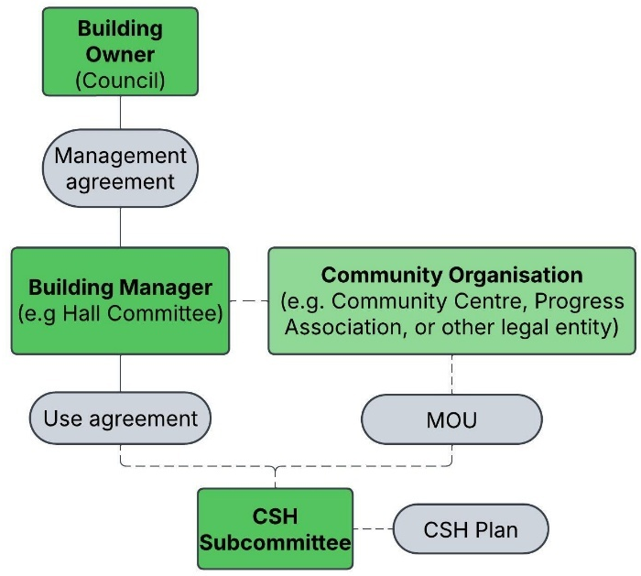 | 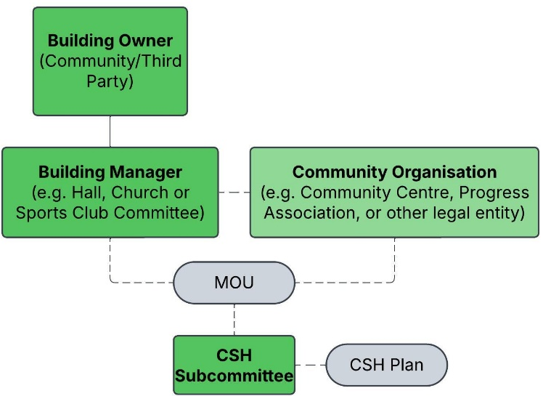

Key roles within the [XXXX CSH] MANAGEMENT TEAM
Name | Role | Email
PERSON
PERSON
PERSON
PERSON
PERSON
Building owner contacts
Name | Role | Email
PERSON
PERSON
Building manager contacts
Name | Role | Email
PERSON
PERSON

Risk management
Refer to the LGA Community Support Hub Guide
The [XXX CSH] will identify and manage risks associated with planning and operating the CSH.
This may include:
- Considering site safety under different scenarios
- Ensuring volunteer protections and safety
- Defining donation arrangements
- Implementing financial controls
- Identifying if the disruption or emergency has impacted the safety of the physical environment, before opening
The CSH management team identifies risks by [ADD HOW THE CSH MANAGEMENT TEAM WILL DO THIS].
These risks are managed by:
- Mitigating risks, by taking actions to eliminate or reduce the likelihood of a risk occurring
- Obtaining appropriate insurance from a suitably licensed insurer (where available).
Risks should be considered in the broader community context, including the potential impacts if community-led assistance and other support services are not in place. The protections available to community volunteers under the Volunteers Protection Act 2001 (SA) should be considered.

Records management
The [XXX CSH] plans to keep records that are necessary, proportionate and appropriate to support governance, planning and operations.
The [XXX CSH] will collect only information that is necessary and relevant, store it securely, limit access to authorised people, and share it only where appropriate and lawful. Records will be proportionate to the scale and purpose of the hub and will be disposed of securely when no longer required.
[DESCRIBE WHAT RECORDS WILL BE COLLECTED AND HOW THEY WILL BE STORED AND DISPOSED OF APPROPRIATELY.]

Insurance
Refer to the LGA Community Support Hub Guide
Before the CSH commences operations, the [XXX CSH] will confirm the insurance arrangements relevant to its operations, volunteers and venue.
This will include confirming, where relevant, who holds each policy, what activities are covered, whether volunteers and spontaneous volunteers are covered, and any conditions, exclusions or limits that apply.
Before finalising this Plan, check that it addresses the Guide’s core planning areas: governance and risk management; purpose and scope; hub location; community and government connections; inclusion, comfort and safety; services offered; volunteering; information and communication; operational procedures; and exercise. Record any gaps, agreed actions, owners and review dates so the Plan remains practical, current and consistent with the LGA Community Support Hub Guide 2026.
Use these practical checks to complete this section:
- Confirm which organisation is the “insured” (i.e., the policy holder) for each policy, and who to contact if the CSH needs to notify an incident or seek guidance.
- Confirm that the CSH’s intended activities (as described in this Plan) are covered, noting that CSHs do not provide services such as case management, medical care, or professional advice.
- Confirm volunteer coverage requirements (e.g., whether volunteers must be registered, inducted or have specific training).
- If the CSH intends to include spontaneous volunteers, confirm whether the insurer requires any additional steps (such as a specific endorsement, or policy amendment) to extend cover to that cohort.
- Confirm policy costs and clarify who is responsible for paying any excess if a claim is lodged.
- Keep a simple record of the outcome (who you spoke to, date, and any agreed actions) and update this section of the Plan if insurance arrangements change.
The [XXX CSH] is covered under the following insurances.
Insurance
Policy (examples) | Policy holder | Contact
Building Insurance
Contents
Public Liability
Association
Volunteer Personal Accident

Resources
AHC Community Support Hub Factsheet – Governance and Insurance, https://www.ahc.sa.gov.au/assets/downloads/community/resilience-and-recovery/2.-Governance-and-Insurance-for-Community-Support-Hubs.pdf?v=1751417118
Institute of Community Directors Australia, Policy Bank, https://www.communitydirectors.com.au/tools-resources/policy-bank
Community Legal Centres (SA), https://www.clcsa.org.au/
Volunteering Australia, Running the risk? A risk management tool for volunteer involving organisations, https://volunteeringaustralia.org/wp-content/files_mf/1377053059VAManagersrunningtherisk.pdf
Justice Connect, Risk management and insurance for community organisations, https://www.nfplaw.org.au/
Legal Services, Commission South Australia, Volunteer Protection, https://www.lawhandbook.sa.gov.au/ch08s15.php
Local Community Insurance Services, https://www.localcommunityinsurance.com.au/home.html

- Hub team roles and responsibilities
The below CSH structure is an example of how volunteers can fulfil the hub's purpose when it opens. CSH management teams may adapt these roles and responsibilities to meet their specific needs, noting that it is essential for robust governance and coverage under the Volunteers Protection Act 2001 (SA) that clearly defined roles and responsibilities are documented and practised.
Volunteer roles and responsibilities should match the scope of activities being provided by the CSH (as outlined in this Plan).
Depending on the scale and complexity of the response, not all roles may be required, or some volunteers may take on more than one role.
Volunteers are made up of two groups: members of the Hub team (registered with the CSH or a partner community organisation) and those who are likely to come forward wanting to help after a specific disruption or emergency (spontaneous volunteers).
Members of the Hub team have key roles and form the Hub team, while spontaneous volunteers may provide surge support under Hub team direction. It is not assumed that spontaneous volunteers have any specific training; if used, they will register on arrival, receive a briefing/induction, be supervised, and work alongside a Hub team member within defined, suitable tasks (A Spontaneous volunteers registration form is provided in Appendix B).
The Hub Lead role will be filled first, followed by the Information Support role and then other Hub team roles. In addition to these roles, a member of the Hub team will be designated as the First Aid Officer and the Child Safe Person[1].

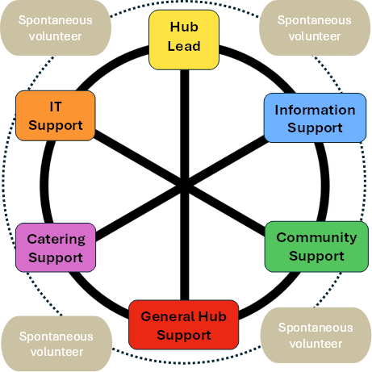

Priority to fill | Role | Ability to | Potential training | Potential background
Always fill | Hub Lead | Coordinate the hub, oversee safety, liaise with agencies, and guide decisions. | Psychological First Aid, CSH operations, basic governance | Emergency services, health, leadership or administration
Fill as a priority | Information Support | Gather, verify and share information, monitor conditions, and support communications. | Psychological First Aid, CSH operations | Information analysis, communications or media
Fill next | Community Support | Welcome and support community members, identify needs, coordinate volunteers, and link people to help. | Psychological First Aid, CSH operations, volunteer leadership | Triage, first aid, volunteer coordination or administration
 | General Hub Support | Support operations, welcome people, help with set-up, and assist the Hub team. | Psychological First Aid, CSH operations | Community work, volunteering or teamwork
 | Catering Support | Provide light refreshments, support kitchen operations, and follow food safety practices. | Psychological First Aid, food safety | Catering, hospitality or food handling
 | IT Support | Set up and support technology, maintain connectivity, and provide basic technical help. | Psychological First Aid | IT, communications or AV support
Only where registration, briefing, supervision, insurance and suitable low-risk tasks are in place. | Spontaneous Volunteer | Provide supervised support for low-risk tasks such as set-up, welcoming and basic logistics.
Role cards have been developed (Appendix A) to support CSH operations by outlining the minimum requirements, responsibilities and constraints for each role. Working within these defined roles safeguards the CSH and the local community.
Spontaneous volunteers will not be allocated tasks that require specialist training, checks or unsupervised judgement. They will not provide medical or health advice, handle medications or personal health information, transport community members, work directly with children or people more at risk without appropriate arrangements, undertake high-risk manual tasks or conduct off-site or unsupervised activities.
The CSH may also develop more detailed role descriptions to guide operations. These can be kept at the CSH and made available to the community on request.
Based on the described roles, volunteers self-select role(s) that best suit their ability, aptitude and previous experience or skills. This will generally be discussed and documented during the planning phase and completed before the CSH opens.
Role | Volunteer Preference 1 | Volunteer Preference 2
Hub Lead | VOLUNTEER A  VOLUNTEER B
Information Support | VOLUNTEER C | VOLUNTEER A
Community Support | VOLUNTEER D | VOLUNTEER B
General Hub Support |  | VOLUNTEER C  VOLUNTEER D
Catering Officer | VOLUNTEER E | VOLUNTEER F
IT Support | VOLUNTEER G
First Aid Officer | VOLUNTEER A | VOLUNTEER B
Child Safe Person | VOLUNTEER C | VOLUNTEER D

Resources
Karori Community Emergency Hub Guide, https://www.wremo.nz/assets/Hub-Guides/Wellington-City/Karori.pdf
State Emergency Management Plan - Guidelines For Managing Spontaneous Volunteers In South Australia Part 2 Strategies, Guidelines And Frameworks, https://www.dpc.sa.gov.au/__data/assets/pdf_file/0010/97129/Guidelines-for-Managing-Spontaneous-Volunteers-in-South-Australia.pdf
Australian Disaster Resilience Handbook Collection. Handbook 12 – Communities Responding to Disasters: Planning for Spontaneous Volunteers, https://www.recovery.sa.gov.au/about-recovery/resources-for-recovery-coordinators/resource-documents/E_SDRCF-2022-Guideline-E-Communication-and-Engagement.pdf
- Site safety
The [XXX CSH] will review site safety during the planning phase and document higher-level safety considerations for the venue. This helps identify known or plausible hazards that could affect safe access, safe occupancy, or continuity of basic services.
Where a hazard is identified, the [XXX CSH] will record whether the risk is acceptable for the intended use of the site. The hazard assessment supports planning and preparedness and does not replace event-specific opening and closing decisions, which are addressed later in this Plan.
The [XXX CSH] will identify and record practical mitigation measures. These may include confirming safe access to the building after a disruption or emergency, identifying backup power or communications options, confirming water, sanitation and cooling arrangements, planning for traffic, parking and accessibility requirements, and preparing clear communication to avoid confusion about the CSH’s role.
Hazard / consideration | Known issue? | Potential after an emergency? | Mitigation measures / controls (examples)
Flooding – Is the site in a mapped floodplain, flood prone area, or subject to localised flash flooding? | ☐ Yes ☐ No | ☐ Likely  ☐ Possible  ☐ Unlikely | - Consider alternative venue.
Bushfire exposure – Is the site in a high bushfire risk area? | ☐ Yes ☐ No | ☐ Likely  ☐ Possible  ☐ Unlikely | - Note bushfire risk, while also re-iterating that the CSH will not open unless safe to do so.  - The CSH may wish to consider building resilience measures such sprinklers to reduce the likelihood of asset damage.
Bushfire Safer Place – Is the site within (or near) a designated Bushfire Safer Place area? | ☐ Yes ☐ No | ☐ Likely  ☐ Possible  ☐ Unlikely | - Record BSP status for situational awareness and community messaging (noting BSPs are built-up areas, not buildings).  - Prepare communications to avoid confusion between CSH and BSP purpose.
Severe weather / storms – Local wind exposure, falling branches/trees, hail, roof vulnerability. | ☐ Yes ☐ No | ☐ Likely  ☐ Possible  ☐ Unlikely | - Check site safety before opening.
Heat risk – Site overheating, lack of shade, internal temperature control limitations. | ☐ Yes ☐ No | ☐ Likely  ☐ Possible  ☐ Unlikely | - Confirm cooling capacity and ventilation; identify the coolest rooms.  - Plan water access, shade and basic heat illness awareness for volunteers.
Traffic and road safety – Known traffic hazards at/near the site (speed environment, visibility, heavy vehicles, pedestrian conflict). | ☐ Yes ☐ No | ☐ Likely  ☐ Possible  ☐ Unlikely | - Consider traffic control measures feasible for volunteers (cones, hi-vis, signage) with approvals where required.  - Consider parking requirements  - Identify accessibility impacts (prams, wheelchairs, low vision).
Power reliability – Are power outages a known issue, or likely after emergencies? | ☐ Yes ☐ No | ☐ Likely  ☐ Possible  ☐ Unlikely | - Identify backup options (generator/solar+battery, power banks) and storage/maintenance responsibility.  - Plan for safe lighting and food safety impacts during outages.
Telecommunications – Are mobile/internet outages a known issue, or likely after emergencies? | ☐ Yes ☐ No | ☐ Likely  ☐ Possible  ☐ Unlikely | - Identify alternative connectivity options (e.g., satellite internet where available) and offline information-sharing methods.  - Plan how to access and display verified information when connectivity is limited.
Water and sanitation – Reliability of potable water and toilets; potential sewerage issues after storms/flood. | ☐ Yes ☐ No | ☐ Likely  ☐ Possible  ☐ Unlikely | - Confirm water source and any constraints; identify options if water is unavailable.  - Plan cleaning supplies and safe use/closure of amenities if compromised.
The [XXX CSH] will review site safety information as conditions change and will update this section as new information becomes available.

- Managing community expectations
The [XXX CSH] will communicate clearly with the community, council and relevant agencies about what the CSH is, what it does, and what it does not do. This will support consistent expectations, reduce confusion with formal emergency arrangements, and help community members understand what support may be available.
The [XXX CSH] will communicate this information during the planning phase and, when open, will reinforce key messages through volunteers, signage, social media and other local communication channels.

Key messages
- The [XXX CSH] is a community-led support hub.
- The [XXX CSH] is not a formal emergency management facility or service delivery centre.
- The [XXX CSH] may open when there is a clear local need, it is safe to do so, and there is enough volunteer capacity.
- The [XXX CSH] will provide the support and services described in this Plan.
- Some services may be affected by volunteer capacity, available resources, building constraints or safety considerations.
- The [XXX CSH] may close or reduce services if community need changes, volunteer capacity is not sustainable, safety changes, or other arrangements take precedence.
- Where relevant, the [XXX CSH] will explain its purpose and boundaries, communicate what services it will and will not provide, use verified information where possible, identify when information is community-sourced and not yet confirmed, communicate known limitations, encourage community self-reliance and mutual aid, and use respectful, accessible and inclusive language.

- Building community awareness and social connections
The [XXX CSH] intends to build community awareness during the planning phase and year-round by sharing clear information about the CSH’s purpose, role and place within the local community. This will help community members understand how the CSH may support preparedness, connection and local recovery, alongside existing groups, services and formal emergency arrangements.
The [XXX CSH] aims to build and maintain relationships with local community groups, services, council and other relevant stakeholders. These relationships will support local coordination, strengthen communication pathways, and help the CSH share timely information before and during disruptions or emergencies.

Community awareness and engagement
Communication approach:
- share information about the purpose and role of the CSH in the community
- build awareness of the types of events or disruptions the CSH may open for
- explain how the community will know if the CSH is open or closed
- share preparedness information from emergency services and other trusted sources
- promote the role of local community connections, mutual aid and preparedness
- support communication with local groups, council and relevant services
Communication by the [XXX CSH] will, be clear and easy to understand, respectful and inclusive, appropriate to the local community, and informed by local needs, strengths and services. Information shared by the CSH will be verified where possible, and the [XXX CSH] will aim to use consistent wording across its communication channels.

Communication channels
- meetings with community groups and community planning sessions
- local noticeboards, emails and printed materials
- social media

Talking to the media
The Hub Lead will act as the CSH spokesperson, unless another arrangement is agreed. The [XXX CSH] may use a media pack or other prepared communication materials to support clear and consistent messaging.
The [XXX CSH] intends to use a [WEBSITE/WEBPAGE/SOCIAL MEDIA], and existing community networks and partner organisations, to build awareness and share information. These channels may be used to communicate the purpose of the CSH, community preparedness information, that the CSH may not always open, how the community will know if the CSH is open or closed, and what support the CSH may and may not provide.
Anyone talking to the media should only comment on what is occurring at the CSH and general impacts on community, they should not provide information about the emergency as this is done by emergency services.
 Name |  Organisation | Email

Resources
AHC Community Support Hub Factsheet – Community connection, https://www.ahc.sa.gov.au/assets/downloads/community/resilience-and-recovery/4.-Building-Community-through-Community-Support-Hubs.pdf?v=1751417129
AHC Community Support Hub Media Pack, https://www.ahc.sa.gov.au/assets/downloads/community/resilience-and-recovery/5.-A-Media-Pack-for-Community-Support-Hubs.pdf?v=1751417135
Australian Red Cross - Communicating in recovery, https://www.redcross.org.au/globalassets/cms-assets/documents/emergency-services/communicating-in-recovery-resource.pdf

- Exercising and reviewing the plan
The [XXX CSH] will test its arrangements before opening for a real event and then periodically as arrangements change. Exercises may include a discussion exercise, a walk-through of the venue, a communications test, a volunteer briefing practice, or a simulated opening and closing decision.
Learnings from exercises will be recorded, assigned to an owner and used to update this Plan, role cards, contact lists, procedures and resource requirements. The Plan will also be reviewed after any activation, exercise, material change to venue, governance, insurance, volunteer arrangements or council support, and at least every two years.

- Funding opportunities
The table below details potential actions and requirements that [XXXX] CSH may pursue, contingent on securing grant funding.
These actions and requirements will be discussed with the [OWNER OF CSH BUILDING] to obtain the landholder’s consent before funding applications are submitted.
The listed actions and indicative costs are provided as examples only. CSH actions and associated costs will vary depending on individual hub plans and capacity.

Funding requirements
Action or requirement | Rationale | Priority | Status | Indicative cost
External and internal signs | Make the CSH easy to find, clearly show when it is open, and identify available services. | Medium | Implemented | $2,500
Hub volunteer t-shirts, caps and name tags | To clearly identify Hub team members and spontaneous volunteers | High | In progress | $700
Website or other social media platform developed | Develop a website and social media presence to promote the CSH | High | In progress | $500
Psychological first aid training | Hub team members will undergo training in psychological first aid to understand self-care and provide support during traumatic situations. | High | Not started | $2,000
First aid training | Hub team members will undergo training in first aid to enable support for community members | High | Not started | $1,600
A secondary power source (e.g. generator or solar panel and battery) | Power outages are likely to occur in an emergency. To support the local community in this instance, the CSH will require alternative power. | High | Not started | $60k to $200K
Satellite internet and connectivity | Telecommunications outages are likely to occur in an emergency. To support the local community in this instance, the CSH will require alternative telecommunications. | High | Not started | $1,600
Power banks and power boards | To enable members of the community to charge or power devices or equipment | High | Not started | $1,100
Battery power radios | To enable those at the CSH to stay in touch with community updates (particularly in a power outage) | High | Not started | $260
Two first aid kits | Provide volunteer and community members with first aid supplies | High | Not started | $490
Community engagement materials | Material for planning workshops | High | Not started | $930
Two mobile whiteboards | Facilitating the sharing of information with community members at the CSH | Medium | Not started | $460

- CSH Operation

Opening and closing the CSH
The Hub Lead, with the Hub team, will use this checklist to support consistent decisions about when to open and close the CSH. The Hub Lead and Hub team will consider these questions before opening and review them regularly while the hub is operating. Safety will come first.
If the CSH opens, the Hub team will clearly communicate this to local community members, council and other partners. Communication methods will be planned in advance and may include:
- raising a physical flag or displaying a sign at the venue
- posting on the CSH’s social media channels and other community sites
- placing flyers at local meeting points
- contacting council and other partners where possible
Opening criteria (before opening) | Tick | Notes / actions
1. Is there a clear community need the CSH can support?  Who is likely to attend and what are their likely needs? | ☐ Yes
2. Is it safe to open and operate?  The CSH should not operate where there is a current threat to the site, including if the site or access route is unsafe, if road closures prevent safe access, if the location is within a ‘Watch and Act’ or ‘Emergency Warning’ area, or on days of forecast Catastrophic Fire Danger Rating for the CSH location. Consider local site-specific hazards and whether conditions can be monitored while open. | ☐ Yes
3. Do we have capacity and capability to open?  Are there enough Hub volunteers available (and not personally impacted) to establish a Hub team. Can we provide at least the minimum services safely? | ☐ Yes
4. What formal arrangements are active, and how will we avoid confusion?  If an ERC or Recovery Centre is (or is likely to be) activated, confirm how the CSH will complement these services and communicate boundaries clearly. | ☐ Done
5. Communications  How will the community know the CSH is open, what it provides (and does not provide), and what to do for help beyond CSH scope? | ☐ Ready
Decision (before opening): ☐ Open ☐ Do not open ☐ Review again at: ____________________

Closing / stand-down criteria (during operations) | Tick | Notes / actions
1. Safety has changed  Public warnings escalate, access becomes unsafe, the building/site is unsafe, or road closures prevent safe operation. | ☐ Yes
2. Community need has reduced  Needs can now be met through individuals’ own supports, restored services, or other arrangements. | ☐ Yes
3. Volunteer capacity is not sustainable  Fatigue, low numbers, or volunteers need to return to their own responsibilities. | ☐ Yes
4. Transition to formal arrangements  An ERC or Recovery Centre has activated, or the venue is required for activation as an ERC (ERC takes precedence and the CSH will either close or transition to support the ERC operations as appropriate). | ☐ Yes
5. Handover and records  Key information captured (e.g., community needs trends, key decisions), privacy managed, and handover completed to council/other arrangements as agreed. | ☐ Yes
Decision (during operations): ☐ Continue ☐ Reduce services ☐ Close / stand down

Supporting impacted community members
Hub volunteers provide support to community members who need it. Volunteers will not provide counselling unless they are qualified and it is within the CSH’s scope. Support will usually involve listening, sharing information and helping with practical needs. Where possible, a comfortable space will be used for this support.
DO these things when providing support:
- Help people feel in control by letting them make their own decisions
- Help people regain their composure in their own time. Sit with them until their emotions settle.
- Listen respectfully, show them it’s important to you and that you want to understand them.
- Encourage them to think about which friends and family they can get support from
- Take note of what people need. They may not be able to express it or ask for it, and you may be able to help find solutions within the Hub.
- Be mindful that people may be responding under stress or frustration, focus on the message rather than the emotion and look after your own wellbeing
- Seek assistance from another member of the Hub team if you have concerns.

DON’T:
- order people around or tell them what to do without explaining why
- tell them not to worry, that it could have been worse or that others are worse off
- talk down or patronise them
- be distracted when they are talking to you, focus on them
- try to talk them out of their feelings
- reassure them that everything will be all right, when it may not be
- react to their anger or other emotions personally
- separate them from those they are with
- get sentimental or excited with them
- deny them privacy or independence when they need it
- talk about your own experiences
- only share facts, not hearsay or rumours

Resources
Australian Red Cross - Psychosocial Support Community toolkit, https://www.redcross.org.au/communitypss/
Australian Red Cross, Psychological First Aid Guide, https://www.redcross.org.au/globalassets/cms-assets/documents/emergency-services/psychological-first-aid-guide-2024.pdf
Australian Red Cross - Communicating in recovery, https://www.redcross.org.au/globalassets/cms-assets/documents/emergency-services/communicating-in-recovery-resource.pdf

Hub resource kit
The [XXX CSH] will maintain a resource kit that can be accessed during power or communications outages. The kit may include a printed copy of this Plan, contact lists, role cards, sign-in and registration forms, opening and closing checklists, site maps, signage, stationery, torches, batteries, basic supplies and communication equipment such as a UHF radio where available.
The CSH management team will document where the kit is stored, who can access it, how it is maintained and when it was last checked.

Public Information Board
When the [XXX CSH] is open, a Public Information Board can be used to display key information for community members and volunteers. The board supports consistent messaging, helps people access current information, and provides a visible point of reference within the Hub.
The Public Information Board is placed where it can be easily seen and accessed without blocking movement through the venue. It’s updated as new information becomes available.

Information displayed on the board can include:
- the date and time information was received or updated
- the location or area affected
- a short summary of what is happening
- the CSH’s current response or actions
- priority actions, including what has been completed
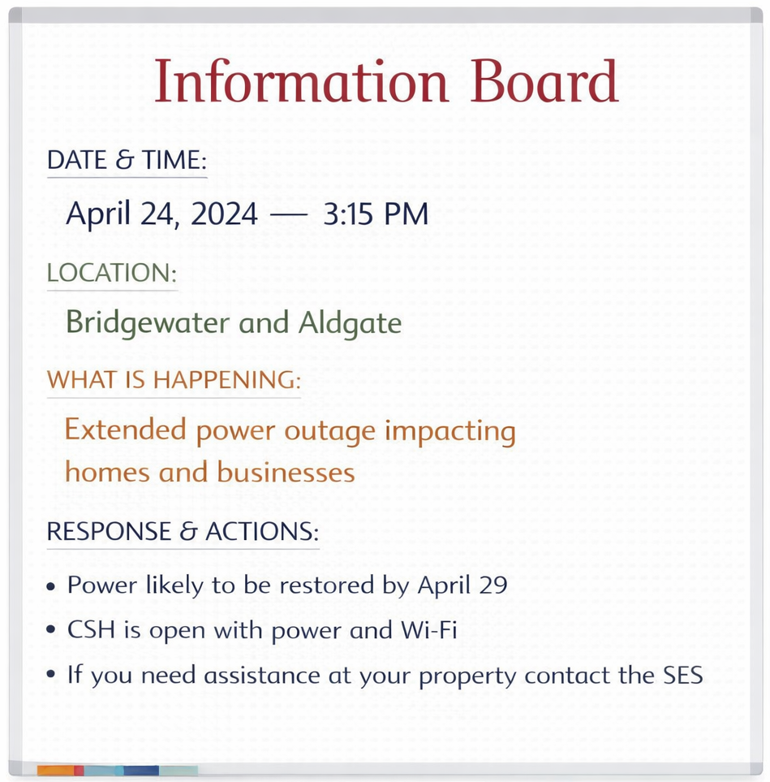

Types of information that may be displayed
- known hazards in the community
- current weather information, where relevant
- the status of essential services such as power, gas, water, telecommunications and transport
- official warnings and advice from emergency services
- information about what support is available through the CSH
- information about other services or organisations that may assist the community.
The information shared by the [XXX CSH] will, as far as reasonably practical, be confirmed as accurate and based on trusted sources.
The [XXX CSH] may hold information sessions when open to share key updates with community members. The sessions may be supported through social media or other local communication channels.

Resources
Bureau of Meteorology, South Australia, http://www.bom.gov.au/sa/?ref=hdr
State Government, essential services outages, https://www.sa.gov.au/topics/emergencies-and-safety/types/utility-outages
Map of transport network, including road closures, https://traffic.sa.gov.au/
Country Fire Service, Incidents and Warnings, https://www.cfs.sa.gov.au/warnings-restrictions/warnings/incidents-warnings/
South Australia State Emergency Services, Current warnings list, https://www.ses.sa.gov.au/incidents-and-warnings/current-warning-list/

Needs and Offers
When open, the [XXX CSH] may help connect community needs with local offers of assistance, including goods, services and practical support. This will help community members use local skills, resources and connections where appropriate.
The [XXX CSH] will generally avoid directly accepting or encouraging donations of material goods, as these can be difficult to sort, store and distribute. If the [XXX CSH] chooses to coordinate donated goods, it will communicate clearly what items are needed and any limits on what can be accepted.
If communication channels are available, the [XXX CSH] intends to use social media and other local networks to share clear messages about what support or goods are needed, what is not needed, and where donations may be directed.
These messages may include:
- specific items needed by community members or required for the operation of the CSH
- that the CSH is not receiving general household donations, and that goods can instead be donated to organisations such as St Vincent de Paul
- where financial donations can be made
When open, the [XXX CSH] may also coordinate community needs and offers of assistance by matching people locally. In this case, the Hub team may use display boards at the venue to show current Needs and Offers so community members can view the information and make contact. The Hub team’s role will be to facilitate local connections, not to receive, store or distribute goods at the hub unless this has been specifically planned.

Managing a Needs and Offers Board
- Record key details: date and time, the person’s name and contact details, and a clear description of the need or offer.
- Check clarity: make sure information is legible, specific and current.
- Facilitate connections: check needs and offers and help link community members where appropriate.
- Escalate significant issues: report major unmet needs or important offers to the Hub Lead so they can be considered and shared with council or other partners where relevant.
- The Hub team will update the board as needs are met, offers change, or information is no longer current.

Resources
GIVIT, https://www.givit.org.au/
St Vincent de Paul Society https://www.vinnies.org.au/national-disasters
Community-powered disaster recovery, https://recovers.org/

Procedures and supporting information
The [XXX CSH] will develop and maintain procedures and supporting information to assist with the safe and consistent operation of the CSH when it opens. These documents support volunteers to understand their roles, follow agreed processes and respond consistently.
These procedures and supporting documents may include, depending on the activities of the CSH:
- Hub team sign-in and sign-out register
- set-up diagram
- pre-opening checklist
- pre-opening site safety risk assessment
- frequently asked questions
- spontaneous volunteer registration form
- induction and briefing checklist
- medicine register form
- community needs register
These documents are available from other CSHs and can be tailored to support local needs.
The Hub will keep these procedures and supporting documents with the Plan or attach them once they are developed.

Resources
State Government emergency relief and recovery information – https://www.housing.sa.gov.au/other_services/emergency-relief
CFS Bushfire Safer Places and Last Resort Refuges, https://bit.ly/4223Fn6
Australian Disaster Resilience Handbook Collection, Planning for Animals Handbook, https://knowledge.aidr.org.au/resources/handbook-animals-in-disaster/
South Australian Local Government Association, Heatwave Guide for Local Government, https://safecom-files-v8.s3.amazonaws.com/current/docs/2020_LGA_HeatwaveGuideforLG.pdf
Child Friendly Spaces: protecting and supporting children in emergency response and recovery, https://knowledge.aidr.org.au/resources/ajem-jan-2014-child-friendly-spaces-protecting-and-supporting-children-in-emergency-response-and-recovery/
Australian Red Cross, People at risk in emergencies framework for South Australia, https://www.dpc.sa.gov.au/__data/assets/pdf_file/0018/34254/People-at-Risk-in-Emergencies-Framework.pdf

Appendix A: Roles Cards
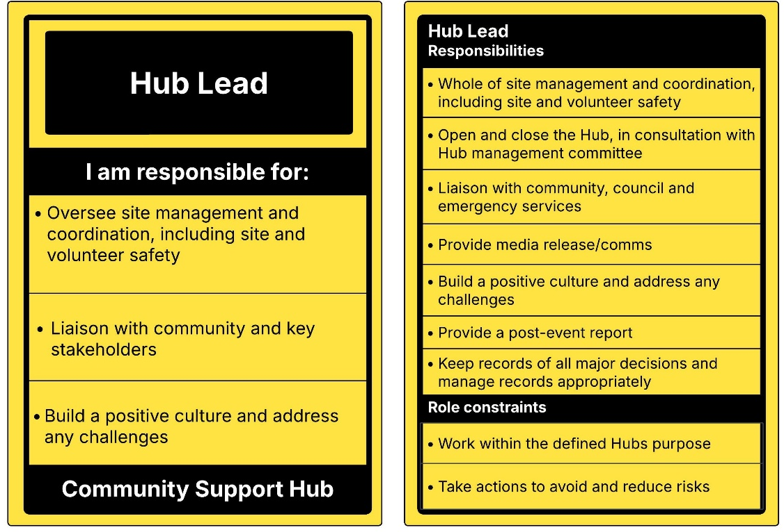

Hub Lead
The Hub Lead oversees CSH site management and coordination to ensure its purpose is being met and that it runs safely and efficiently.
This includes ensuring safety is managed, all the tasks are being done, basic needs are addressed, and significant decisions are discussed and agreed upon with the Hub team.
Depending on the size and duration of the emergency, the Hub Lead may need additional help to fulfil these responsibilities and may assign extra people to assist.

Responsibilities and tasks

Site management and coordination
- Manage site and volunteer safety.
- Make sure roles are allocated, and volunteers are not working in isolation.
- Ensure decisions are discussed and agreed upon with the Hub team
- As much as possible, make sure volunteers have what they need to do their job.
- Hold Hub meetings at the start and end of every day. At the start of day induct volunteers to the building and discuss priorities.
- Keep appropriate financial records to ensure transparency and accountability.
- Consider and manage donations and gifts.

Open and close the Hub
- Ensure the Hub opens when it is safe do so.
- Monitor the situation, closing the Hub if required.
- Permanently close the Hub.
- Communicate opening and closing with community, council and key stakeholders.

Liaise with community, council, and emergency services
- Coordinate and maintain effective communication with community, council, and emergency services to ensure smooth and effective operations.
- Share emergency services' official warnings and advice.
- Initially, communicate the immediate needs of the community, followed by discussions of ongoing support. When ERCs or Recovery Centre are likely to or have already opened, liaise with personnel daily.

Provide media release/communications
- Be the spokesperson for the Hub, referring to the Media Pack for supporting information.

Build a positive culture and address any challenges
- Foster a positive culture within the CSH by encouraging collaboration, open communication and mutual respect among volunteers and the community.
- Ensure volunteers take adequate breaks and support their wellbeing.
- Address challenges by identifying their cause and supporting volunteers in finding solutions.

Provide a post-event report
- Compile and present a report that summarises the event, including activities, outcomes, and lessons learned to guide future community assistance CSH work.

Keep records of all major decisions and manage records appropriately
- Use a logbook, or other document management system, to record major decisions.
- Apply records management to collect, store, use, share and dispose of information appropriately.

Role constraints

Work within the defined purpose of the Hub
The CSH must operate within its defined purpose (as outlined in the Community Support Hub Plan) to protect volunteers and help manage community expectations.

Operating within pre-defined activities, policies and procedures
The CSH is limited to the activities, policies, and procedures it has established, including decisions on whether to engage spontaneous volunteers, accept donations, or allow animals.

Take action to avoid and mitigate risks
- Regularly assess potential hazards and take proactive measures to avoid or mitigate them.

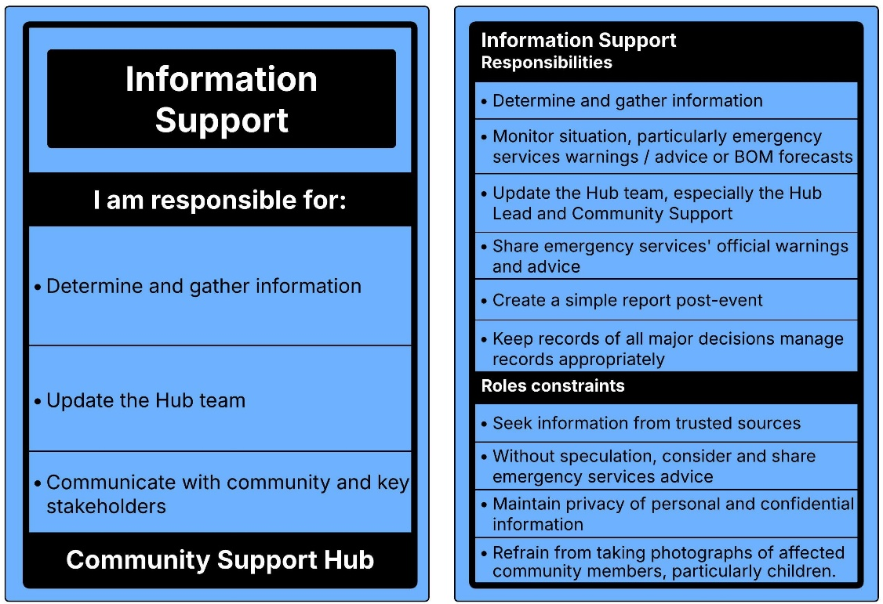

Information Support
The Information Support role is responsible for gathering and, wherever possible, verifying information before sharing it with Hub volunteers, the community, and key stakeholders.
This includes identifying the information needs of the CSH gathering and sharing information on the situation, available support services, and community needs. The role also includes coordinating Hub meetings, providing a shared space for the community, preparing media releases, managing social media/hub website and keeping everyone updated.
Responsibilities and tasks

Determine and gather information
- The Hub team will require current information on the situation, available support services and the ongoing needs of the community.
- This information should come from trusted sources, such as ABC radio, Alert SA, CFS/SES websites and Council as well as from the community. Wherever possible verify information by cross-checking multiple sources.

Monitor the situation
- It is a priority to monitor the current situation to determine if the CSH can continue operating safely. Information can be gathered from emergency services’ warnings and advice, BOM forecasts, and discussions with council

Update the Hub team
- As information is gathered keep the Hub Lead and volunteers with the Community Support role up to date.
- Share emergency services' official warnings and advice.
- Coordinate regular meetings to discuss the situation, set priorities, assign tasks, and address communication and administrative needs. These meetings are also a good opportunity to check on volunteer wellbeing and identify any challenges.

Consider creating and maintaining a Situation Board
- A situation board can be used to display current information, providing a clear picture of what is happening. This may include maps of the area, details on what happened, what the CSH needs to know, what the CSH is doing, and priority tasks.

Communicate with the community and key stakeholders
- Use clear signage and communication channels to inform the community the Hub is open.
- When the Hub is closing, use signage to inform the community that the CSH will no longer be open and provide information on where they can find additional assistance.

Prepare media and communication releases
- In line with the CSHs Media Pack, prepare media and communication releases, noting that the Hub Lead is the only spokesperson.

Establish a social media presence (or other communication channels)
- Establish a social media presence to convey and receive information in a timely manner.
- Monitor social media activity on the CSH site and other reliable sources to gather information on the situation, available services, and community impacts.
- Other communication channels such as telephone trees and community notice boards may also be used.

Create a simple report
- Create a simple report outlining what is occurring in the community, what the CSH is doing to address community needs, and share it with the Hub team, council and key stakeholders.
- These reports should be done daily or on a regular basis to meet the needs of the event.

Keep records of all major decisions and manage records appropriately
- Use a logbook, or other document management system, to record major decisions.
- Apply records management to collect, store, use, share and dispose of information appropriately.

Role constraints

Seek information from trusted sources
- Information should be obtained from trusted sources and verified wherever possible. This is particularly important when sharing information with the public.

Without speculation, consider and share emergency services advice
- Misinformation during and after emergencies can be a significant challenge. When sharing emergency service information, it's crucial to avoid speculation and ensure warnings and advice are based on facts from official sources. This helps maintain public trust and supports effective decision-making.

Maintain privacy of personal and confidential information
- Ensure that all personal and confidential information is handled ethically and securely to maintain the privacy and trust of community members.

Refrain from taking photographs of affected community members
- Volunteers should not take photographs of affected community members, particularly children and young people. Photographs should be non-identifying images only, such as set up activities, close ups that do not show faces (e.g. hands or equipment), or the Hub team, and used solely for the direct purposes of the CSH.
Note: Providing the community with information helps everyone make informed decisions about how to help themselves. Even if the CSH doesn’t have the capacity to help in a more practical way, sharing information remains an important service.

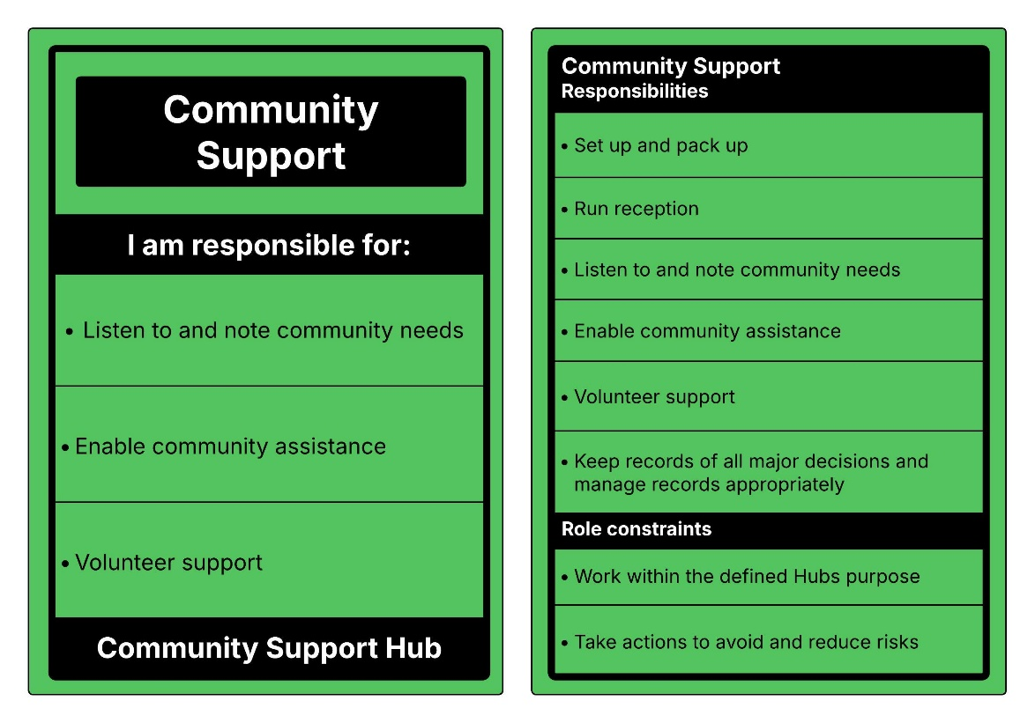

Community Support
The Community Support role aims to ensure that community members receive appropriate support, helping things run smoothly and effectively until additional support arrives. Additionally, this role serves as the main contact for spontaneous volunteers.
The role includes setting up and packing up, managing reception, conducting community needs assessments, facilitating community support, supporting volunteers, and keeping records. Maintaining accurate records and financial transparency is essential for accountability and trust within the community, including effective records management.
This role may be well suited to also take on the responsibilities of a First Aid Officer and Child Safe Person.

Responsibilities and tasks

Set up and pack up
- Complete a perimeter and building safety check.
- Ensure the toilet is accessible and ready for use and there is a hand washing station.
- Ensuring all necessary equipment and materials are in place when the CSH opens and properly stored away when the CSH closes to maintain an organised and efficient environment.

Reception
- Assign a General Hub Support volunteer to run the CSH reception, ensuring community members are welcomed, and understand what the CSH can and cannot offer.

Community needs
- Listen to and note the needs of affected community.
- Communicate these needs to the Hub Lead regularly.

Community assistance
- Offer support to those who need it. Support can be provided by listening, sharing helpful information, offering practical assistance and providing a quiet space. Volunteers are not counsellors.
- Inform people in need of assistance of individuals, community groups, services or resources that may be able to offer support or relevant information. (Note: individuals offering assistance are not Hub volunteers).
- Connect with community groups and services to learn what support they can offer, while keeping people’s personal details private.

Maintain volunteer sign-in / sign-out and registration
- Ensure all volunteers sign-in at the beginning of their shift and sign-out at the end to maintain accurate records of volunteer participation.
- Ensure spontaneous volunteers fill in a basic registration form (Appendix B).
- Ensure information is collected, stored, used, shared, and disposed of appropriately.

Develop and maintain volunteer roster
- Consider the daily opening hours and make a roster. Ensure no one works for too long and everyone has opportunities to take breaks and rest.
- When developing the roster, assist volunteers to select a suitable role based on their experience, skills and availability.
- Where spontaneous volunteers are engaged, they work directly with a member of the Hub team and have suitable roles.
- Regularly update the roster to reflect any changes.

Support volunteers when the Hub is open
- Provide role induction to volunteers and supporting information.
- Ensure volunteers have the resources and support they need to perform their roles effectively.
- Make sure everyone takes regular and adequate breaks and are fed and hydrated.
Note: If volunteers don’t look after their own needs, they are more likely to suffer stress. If someone is finding the work stressful or looks stressed, they should consider changing roles, taking a break, or going home. Hub volunteers may also need to recognise signs of stress in others and encourage each other to take regular breaks.
Fatigue management will be planned before and during CSH operations. The Hub team will plan for the possibility of a prolonged event, use rosters that minimise long shifts, ensure volunteers take regular breaks, have access to food, water and time away from high-demand roles, and rotate people where possible.
Volunteers should use a buddy approach, look out for signs of tiredness or distress, and speak up early if they are tired, unwell or need to step away. If volunteer capacity is not sustainable, the Hub Lead should consider reducing services, changing opening hours or closing the CSH.

Keep records of all major decisions and manage records appropriately
- Use a logbook, or other document management system, to record major decisions.
- Apply records management to collect, store, use, share and dispose of information appropriately.

Role constraints

Work within the defined Hubs purpose
- The CSH should operate within its defined purpose, which is outlined in the Community Support Hub Plan. Working within these guidelines helps safeguard volunteers and manage community expectations.

Take action to avoid and mitigate risks
- Regularly assess potential hazards and take proactive measures to avoid or mitigate them.

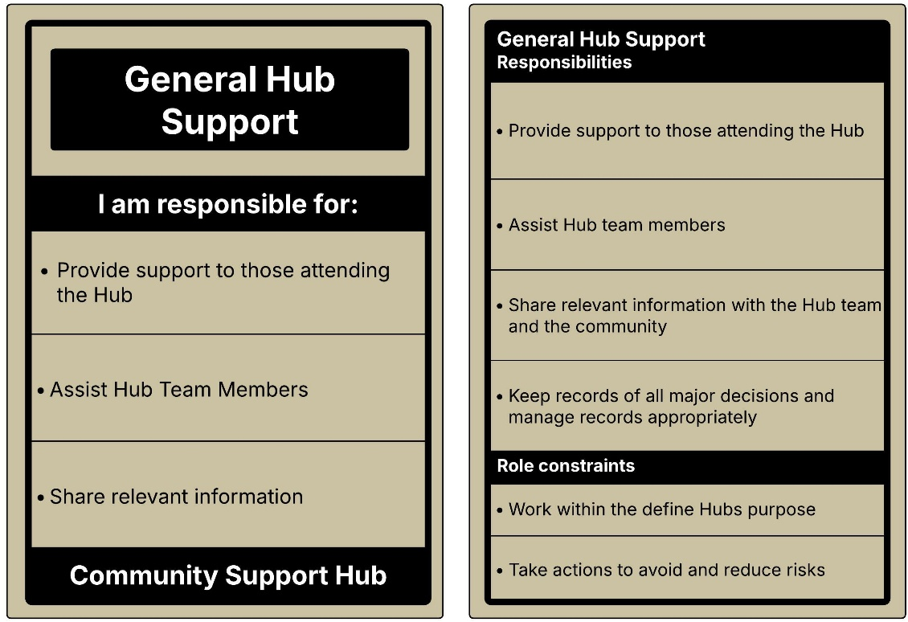

General Hub Support
The role of General Hub Support assists the Hub team. This role is suitable for those who are volunteers with a general awareness of Hub activities.
This role involves providing support to CSH attendees, assisting members of the Hub team and sharing relevant information. It is supportive in nature, with no or limited training and minimal induction required.
Responsibilities and tasks

Provide support to those attending the CSH
- Quietly sit with and listen to those affected
- Take note of what people might need
- Only support to those that need it. Do not try to counsel them. Volunteers are not counsellors. You can provide support by listening, giving information, and providing practical assistance.

Assist the Hub team
- Work alongside a member of the Hub team to achieve tasks.

Share information
- Share information with Hub volunteers, regarding the current situation, available support services and the needs of individuals or the community.
- Share information with the community without any presumptions.

Role constraints

Work within the defined Hubs purpose
- The CSH should operate within its defined purpose, which is outlined in the Community Support Hub Plan. Working within these guidelines helps safeguard volunteers and manage community expectations.

Take action to avoid and mitigate risks
- Regularly assess potential hazards and take proactive measures to avoid or mitigate them.

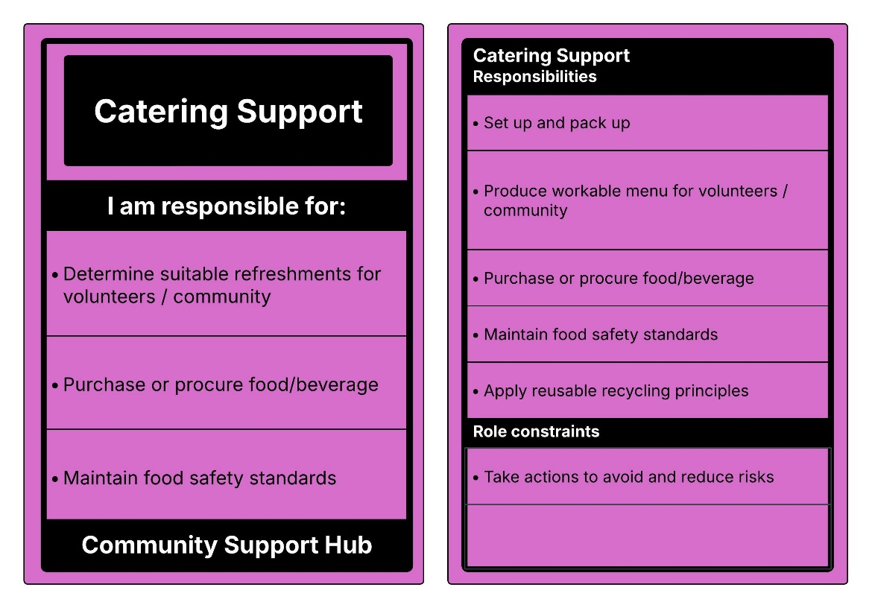

Catering Officer
The Catering Officer coordinates the provision of light refreshments at the CSH, ensuring food safety standards are maintained.
This role includes setting up and packing up the kitchen, determining suitable light refreshments for volunteers and community members, sourcing food and beverages, following reusable and recycling principles, and completing laundry tasks as required.
Responsibilities and tasks

Set up and pack up
- Setup and pack up the kitchen for the purpose of supporting volunteers and affected community.

Produce workable menu for volunteers / community
- Determine suitable light refreshments which align with the purpose of the CSH (noting, refreshments could be tea/coffee and biscuits, snacks, or more substantial meals).

Purchase or procure food/beverage
- Acquire food and beverages, planning a day in advance.

Maintain food safety standards
- Ensure all food and beverages provided are prepared, stored, and served in a hygienic manner to prevent foodborne illnesses.
- Do the laundry as needed to help the CSH run smoothly.

Apply reusable and recycling principles
- Where possible, try to use eco-friendly practices including recycling, using compostable tableware, sourcing local ingredients and minimising food waste.

Role constraints

Take action to avoid and mitigate risks
- Regularly assess potential hazards and take proactive measures to avoid or mitigate them.
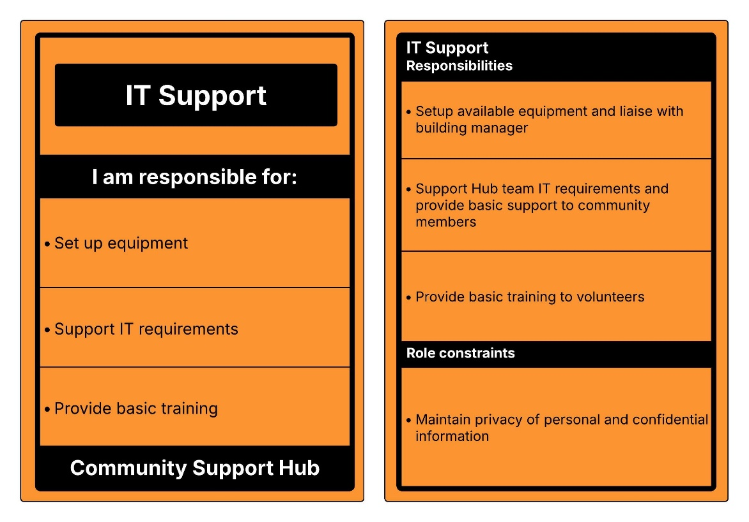

IT Support
IT Support is responsible for information technology and telecommunications at the Hub.
This includes setting up equipment, liaising with the building manager, supporting IT needs, and providing basic training to volunteers.

Responsibilities and tasks

Set up available equipment
- Set up available equipment which may include satellite internet, generator, CSH laptops, power boards, AV equipment or UHF radios.
- Liaise with building manager about the use of venue equipment.

Support IT requirements
- Where requested aim to support IT requirements of volunteers and connecting community members to Wi-Fi or other basic support.

Provide basic training to volunteers
- Where possible provide basic training to volunteers.

Role constraints

Maintain privacy of personal and confidential information
- Ensure that all personal and confidential information is handled ethically and securely to maintain the privacy and trust of community members and relevant partners
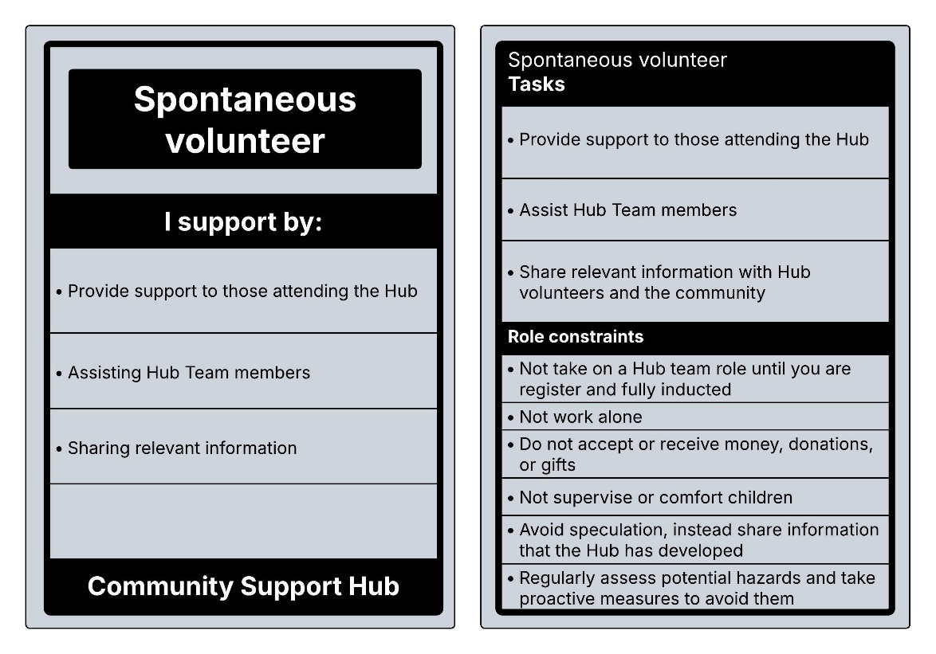

Spontaneous volunteers
Spontaneous volunteers assist the Hub team. This role is suitable for those who are not registered volunteers but wish to help after an emergency or event.
This role involves providing basic support to adults who attend the CSH, assisting members of the Hub team and sharing relevant information. It is supportive in nature, with no or limited training and minimal induction required.
Note: All spontaneous volunteers must register as soon as they arrive at the CSH. This will be completed by a member of the Hub team.

Responsibilities and tasks

Provide support to adults attending the CSH
- Quietly sit with and listen to those affected
- Take note of what people might need
- Only support those who need it. Do not try to counsel them, provide support by listening, giving information and practical assistance.
Children should be supervised by their parent, guardian or carer. If children are alone, they need to be supervised by a Child Safe Person.

Assist the Hub team
- Work alongside a member of the Hub team to achieve tasks
- Follow the directions of Hub team members

Share information
- Share information with Hub volunteers on your observations and the needs of individuals or the community
- Share information with the community without any presumptions.

Role constraints
- Do not take on a Hub team role until you are registered and inducted
- Do not work alone, always work alongside a member of the Hub team
- Do not accept or receive money, donations, or gifts
- Do not supervise or comfort children
- Avoid speculation, only share information that has been verified by the Hub team
- Regularly assess potential hazards and take proactive measures to avoid them

Appendix B: Spontaneous Volunteer Registration Form
Volunteer Details
Field | Response
Full name:
Preferred name (if different):
Date of birth: | ____ / ____ / ______
Residential address:
Phone (mobile):
Email:

Emergency Contact(s)
Primary contact | Response
Name:
Relationship:
Phone (mobile):

Secondary contact | Response
Name:
Relationship:
Phone (mobile):

Health & Safety / Medical Information (For safety and duty-of-care purposes only.)
Relevant medical conditions: | Response
Allergies:
Medications you may carry/use:
Accessibility requirements:
Consent for first aid if required: | ☐ Yes ☐ No

Role Preferences
Preference / Limitation | Details / Selection
Tasks I prefer to do (e.g., Making tea or coffee, basic admin)
Tasks I prefer to avoid / cannot do (e.g., Working directly with community members attending the CSH)

I understand that I am responsible for being aware of my own physical limitations and for advising if there are tasks I am unable or uncomfortable to undertake. I agree to promptly inform the Hub Lead or a member of the Hub team if I am not comfortable performing an assigned task.
☐ Yes ☐ No

Code of Conduct — Acknowledgement
I have read and agree to follow the Community Support Hub Code of Conduct, including behaviour expectations, safety requirements, and privacy obligations.
Initials: ______________________________ Date: ____ / ____ / ______

Privacy Notice & Consent
I understand my information is collected for volunteer coordination and safety, stored securely, and accessed only by authorised Hub personnel or relevant authorities. We only collect the information we need for safety and coordination, and we keep it secure.
I consent to the collection and use of my information as described.
Signature: ______________________________ Date: ____ / ____ / ______

Optional:
Consent to future contact about training/exercises: ☐ Yes ☐ No
Photography consent: ☐ Yes ☐ No
Consent to joining the CSH mailing list: ☐ Yes ☐ No

Signature & Verification
Volunteer signature: ______________________________ Date: ____ / ____ / ______
Hub Support verification: ___________________________ Date: ____ / ____ / ______
Hub Support notes:

Admin Use Only
Briefing and induction completed ☐ Yes ☐ No
Filed: ☐ Yes By: ______________________________ Date: ____/____

